**CVI620/ DPS920 Worksheet 5- Morphology and Geometric transformations**

1. Consider rotating the shown image 90 degrees counter clock wise around point (100, 100) as shown.

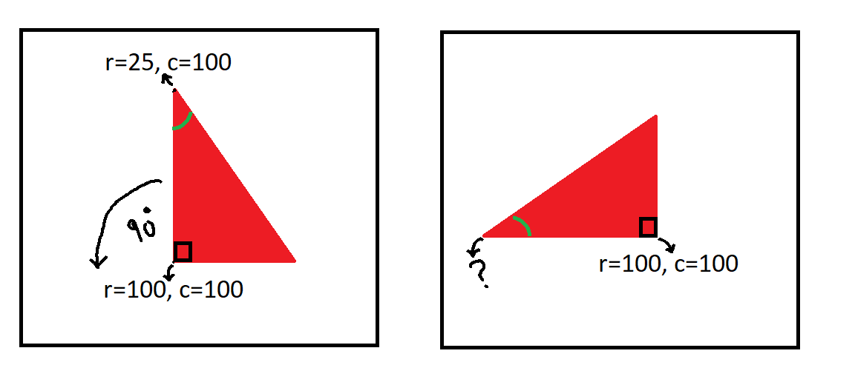

1. What is the transformation matrix?
2. What is the new coordinates of the point at row 25 and column 100 after the above rotation?
3. 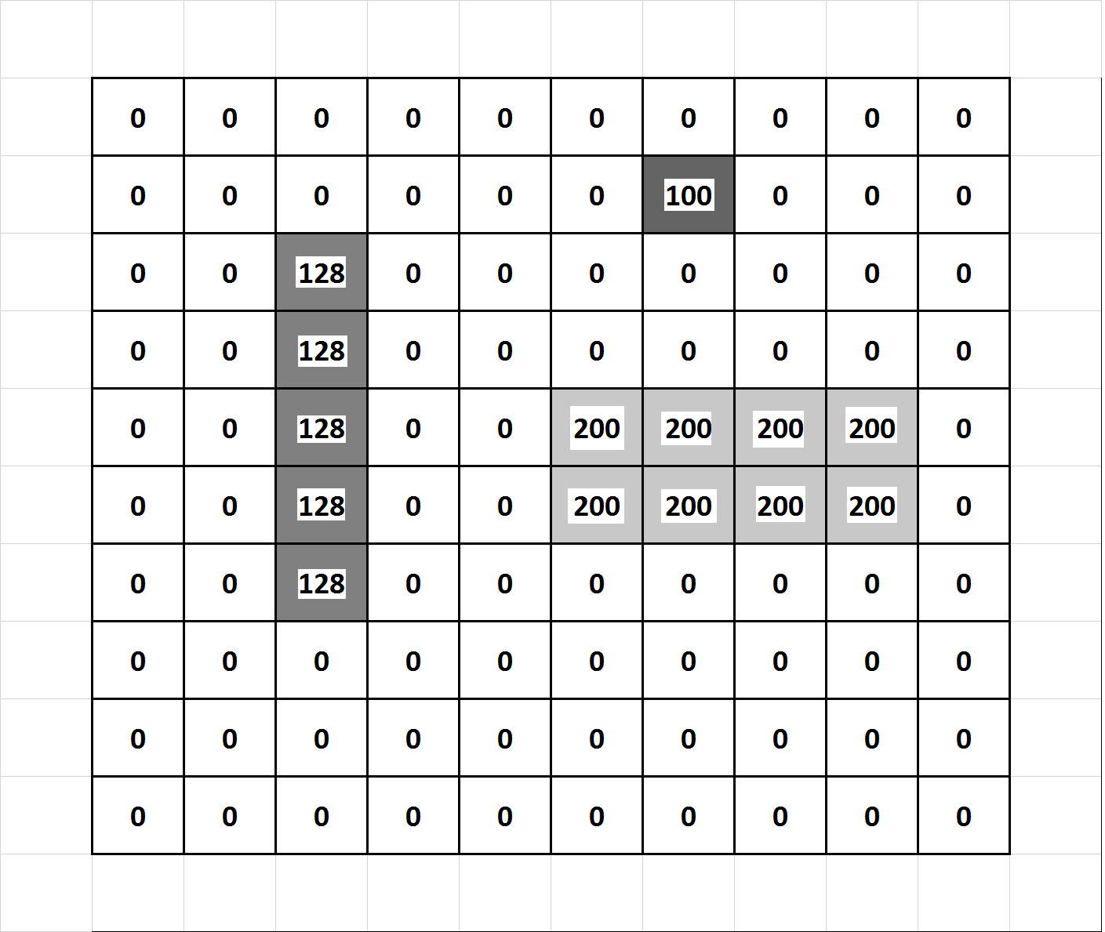Given the following 10 x 10 image
4. Dilate the image using a 3 x 3 square kernel

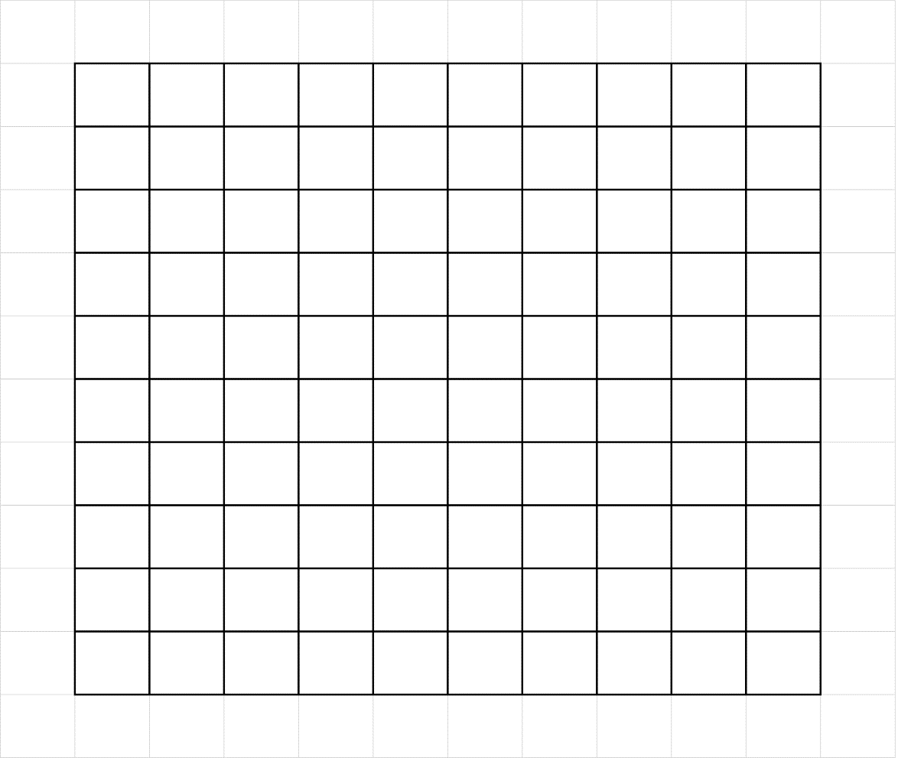

1. Erode the dilated image using a 3x 3 square kernel (Close)